NAME ___________________________________________________
BAND BINGO!
Pick a card to start playing. Choose a place, practice there for 10 minutes and have a parent or guardian sign the space. Turn completed cards in for prize drawings. A Vertical, horizontal or diagonal bingo = 1 entry. Blackout = 2 entries.
Card A

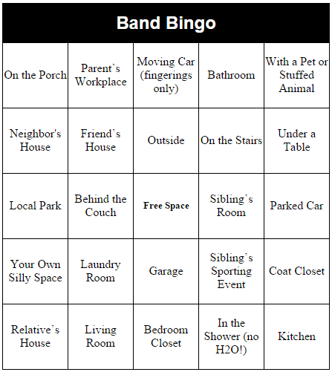

NAME ___________________________________________________
BAND BINGO!
Pick a card to start playing. Choose a place, practice there for 10 minutes and have a parent or guardian sign the space. Turn completed cards in for prize drawings. A Vertical, horizontal or diagonal bingo = 1 entry. Blackout = 2 entries.
Card B

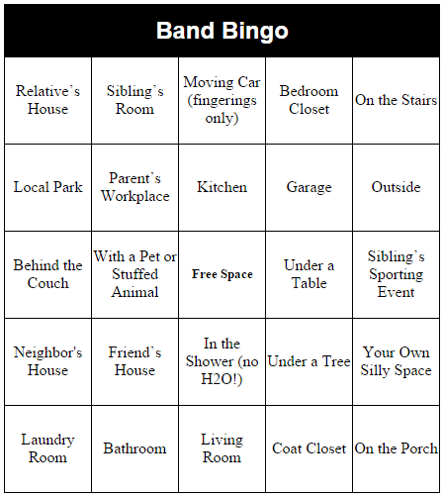
NAME ___________________________________________________
BAND BINGO!
Pick a card to start playing. Choose a place, practice there for 10 minutes and have a parent or guardian sign the space. Turn completed cards in for prize drawings. A Vertical, horizontal or diagonal bingo = 1 entry. Blackout = 2 entries.
Card C

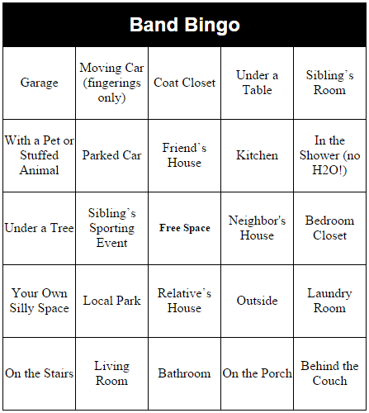

NAME ___________________________________________________
BAND BINGO!
Pick a card to start playing. Choose a place, practice there for 10 minutes and have a parent or guardian sign the space. Turn completed cards in for prize drawings. A Vertical, horizontal, diagonal or diagonal bingo = 1 entry. Blackout = 2 entries.
Card D

